**MD RAYHAN**

mdrayhan40301@gmail.com | (+880) 1909870274

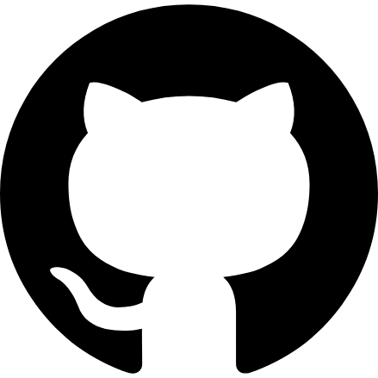

**SKILLS**

❖ HTML, CSS, TailwindCSS  
❖ React.js, Node.js, Express.js, MongoDB  
❖ MERN Stack  
❖ RESTful APIs and Database Management

**EDUCATION**

❖ **Honors First Year | English Department**  
Kabi Nazrul Govt. College | Ongoing | 2023 - Present

* Actively applying creativity and critical thinking from my humanities background to web development projects

**EXPERIENCE**

❖ **Freelance Web Developer**

• Worked on designing and developing web applications using the MERN stack

• Created user-friendly interfaces based on project requirements

• Participated in open-source projects, learning from collaboration with other developers and designers

• Applied best practices to ensure the performance and quality of web applications

**ACADEMIC PROJECTS**

**Upcoming Web Development Projects**

* Engaging in hands-on projects to apply web development skills
* Developing scalable web solutions and exploring modern technologies

**POSITION OF RESPONSIBILITY**

❖ **MERN Stack Lead | Batch Group** (2024 - Present)

* Leading efforts to enhance MERN stack skills within the batch group
* Organizing and conducting workshops and coding sessions to improve and share MERN stack expertise
* Facilitating a collaborative learning environment for peers interested in web development

**ACHIEVEMENTS / HOBBIES**

Passionate about web development and continuous learning  
● Active contributor to coding communities and open-source projects

● Engaged in coding challenges and staying updated with industry trends